Thomas Loder and Jacob Wooten

GEOG 489/689 Final Report

May 6, 2014

Objectives

After doctors complete medical school, they then do a residency in a broad specialization (neurology, surgery, psychiatry, etc.). Once this is completed many then choose to continue their training through a fellowship in a subdiscipline of their chosen specialization. For neurology, the United Council of Neurologic Subspecialties (UCNS) accredits and maintains a listing of all fellowships hospitals, including those for headache (http://www.ucns.org/). Our client, Dr. Elizabeth Loder of the John R. Graham Headache Center at Brigham and Women’s Faulkner Hospital in Boston, wants to have static and interactive maps of all headache fellowships to present at conferences and eventually include in publications. While the UCNS website is very informative, it does not have any strong visual elements and lacks any spatial representations about the locations and distribution of headache fellowships (see Figure 1). Therefore, the maps made in this project may eventually be pitched to UCNS to include as part of their database.

The specific objectives were:

* Map the locations of headache fellowships and post-practice fellows
* Produce a searchable map of fellows and fellowships
* Build a flow map displaying migration of fellows post-fellowship
* Create map of all headache practitioners in the United States (not achieved)

Data/architecture/technology

Data for this project was obtained both from the UCNS website and from a survey of headache fellowship directors conducted by the client. The website and maps were written using a combination of HTML/KML and Java Script. Databases were made using Google Fusion Tables and KML was exported from static maps made in ArcMap. Maps were constructed using both Google Maps API and ArcGIS Online. In order to get the data from the fusion tables to display in Gmaps, we used a template created by Derek Eder (<http://derekeder.com/searchable_map_template/>). This template also allowed for the map to be searchable through a combination of JQuery and CSS.

Results

We succeeded in completing the first three objectives. The last objective we were unable to complete because the client did not in fact have that data as initially suggested. The main page (see Figure 2) is fully searchable with a radius of up to 500 miles from any address for both headache fellowships and the practices of fellows who have completed their fellowships (users can search within 1, 5, 10, 20, 50 and 100 mile radii). The data and symbology can be updated within the Fusion Table (see Figure 3. The map also contains check boxes which allow the user to filter whether they want to search for fellowships, post-practice fellows or both.

The third objective was completed through three different visualizations. Visualization 1 (see Figure 3) utilizes data generated in ArcMap that was then exported to KML to be displayed as a layer in Gmaps. Each color corresponds to a different original fellowship, thus allowing for users to easily trace the flow of doctors between each fellowship. Visualization 3 (See Figure 4) uses the same data converted to KML for Visualization 1, however, this data was published directly to ArcGIS Online. This has the advantages of being able to display an ArcMap generated legend and to maintain all of the symbology used in ArcMap, much of which is missing (especially the proportional weights which show the number of fellows produced by each clinic). Visualization 4 (see Figure 5) uses the converted KML within Fusion Tables to produce the flow map within Gmaps. While importing KML into Fusion Tables is quite a simple process, icons are limited within Fusion Tables and one cannot directly import any Arc symbology, thus this map has less functionality than Visualizations 1 and 3.

Reflection

The client was very easy to work with and is very impressed with the results from the project. One of the major issues was the speed at which the client was able to deliver initial data, as it had been implied at the beginning of the project that all data was immediately available. This did not pose a tremendous problem, as we were able to implement the data quite quickly once we received it. We were, however, unable to complete the final objective as the data for the location of all headache providers was not yet fully gathered and the client decided that the product that had already been delivered was satisfactory.

Both team members contributed equally to this project. Thomas focused creating the Fusion Table database as well as working within ArcMap and then converting that data to KML for inclusion in the visualizations. Jacob focused on web design and was the discoverer of both Fusion Tables and the template that helped with the searchable map. These two discoveries were extremely important, as we had been struggling with how to import the data beforehand.

In terms of challenges the biggest problem was getting the flow maps to display using all of the symbology. While it is easy to export KML and have it display in Gmaps with or without Fusion Tables, Arc symbology does not transfer very easily and some not at all. Points must be stored as separate image files and then written into the code. While Fusion Tables are very easy to use, the symbology and functionality is limited and the data is not as secure as if it were stored in a SQL database. Therefore, if this project were to be improved upon in the future, we would likely store the data within a database. Similarly, while ArcGIS online is not as easy to work with as Gmaps given the use of Dojo, it does allow for greater processing technology. However, it would not be considered as an option given difficulties in programming.

Next steps

The first thing that will be done is to refine the existing maps. This would include better styling, whether through exporting better KML or within HTML/Java Script. A specific thing that needs to be added to the Gmaps representation is a legend, as currently is not terribly clear what is being represented. We attempted to add a legend, however, we could not get it to display. The second thing would be to gather more data. This would then allow us to get more specific locations for each of the fellows’ locations (currently only at the city or state level) and allow us to fill in gaps from fellowship directors that did not respond to the survey. Once these steps are complete, it would be ideal to include maps in presentations at medical conferences and in journal articles.

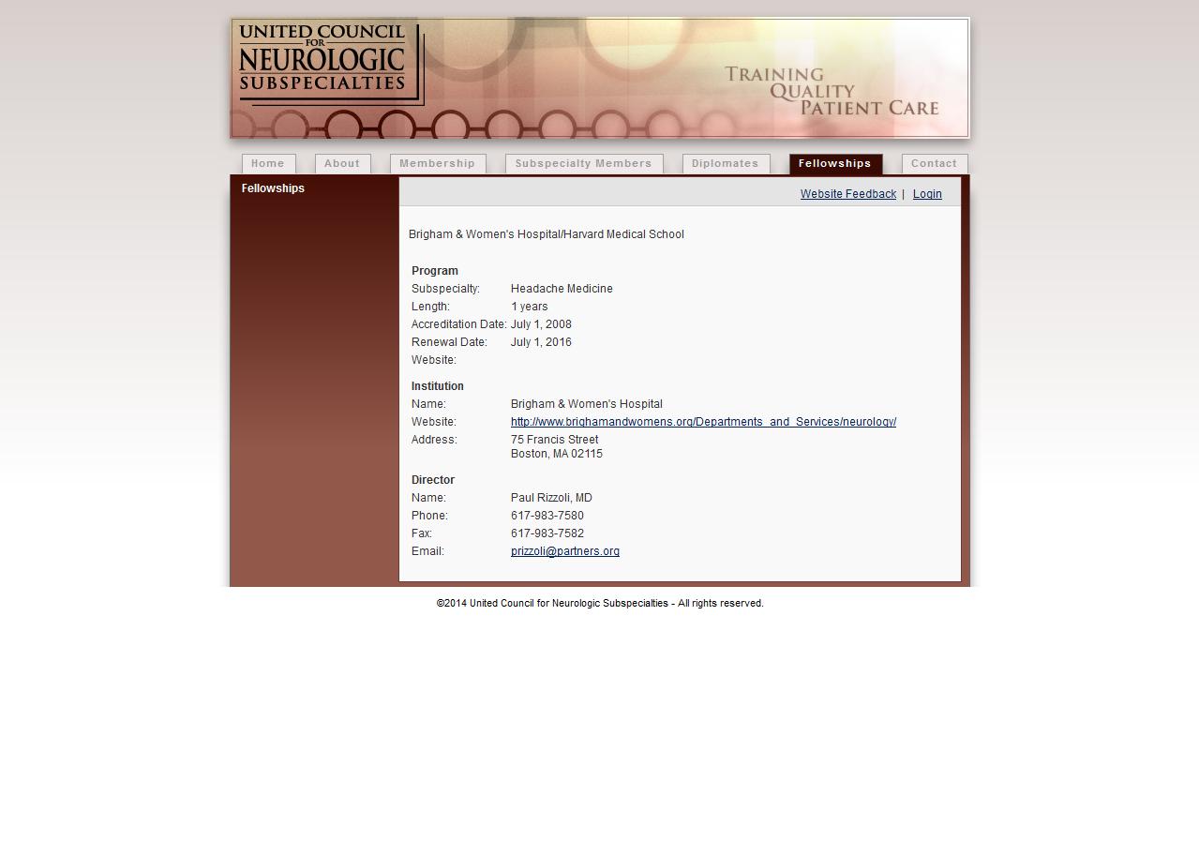

**Figure 1: An example UCNS database entry**

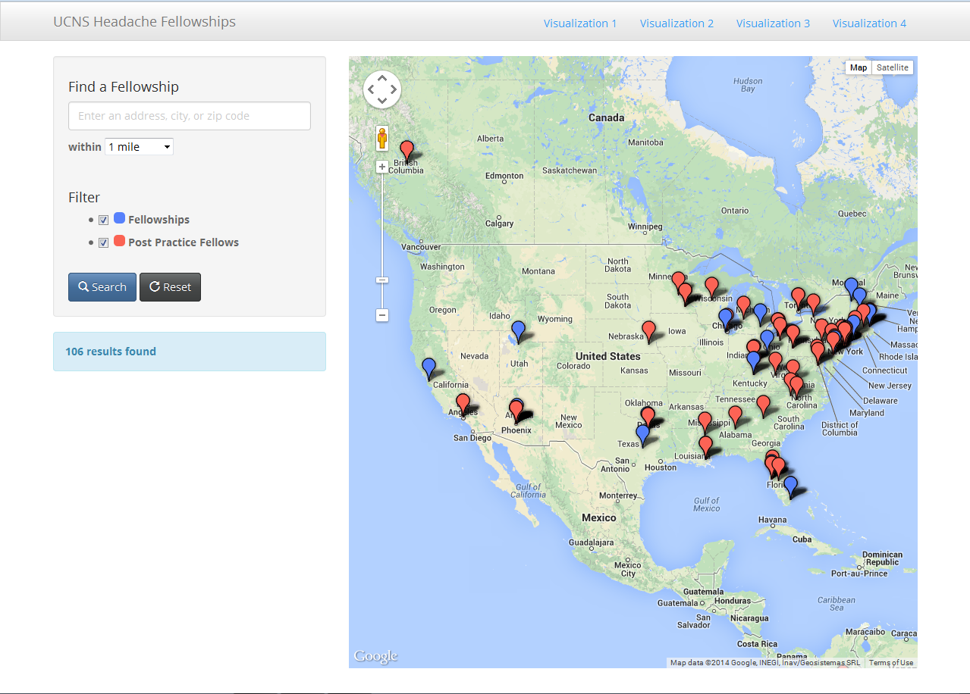

**Figure 2: The main page with searchable map and spatial distribution of headache providers**

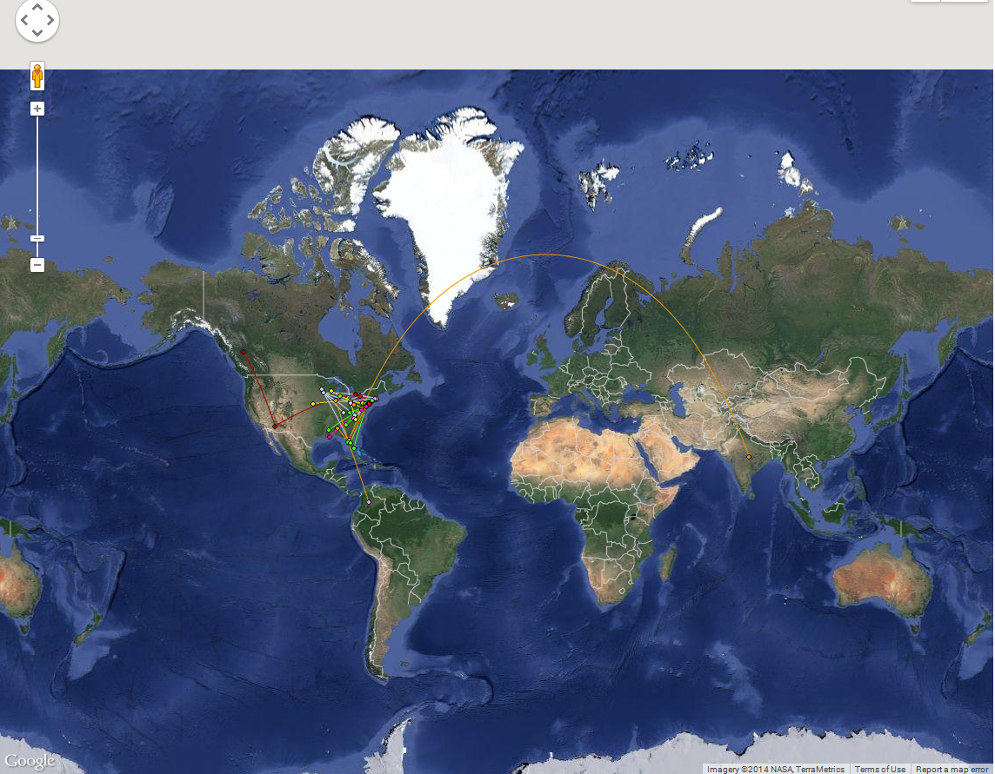

**Figure 3: A KML Gmaps example not using Fusion Tables**

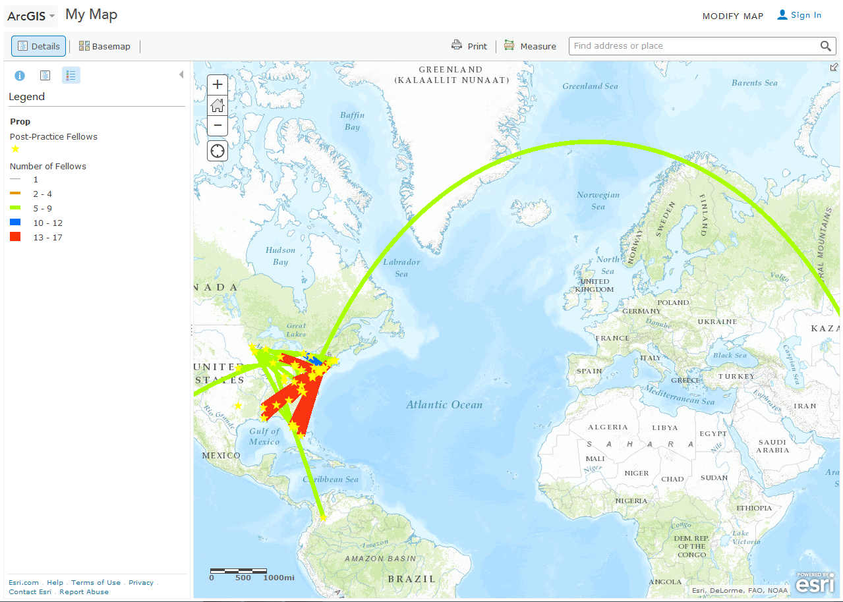

**Figure 4: An ArcGIS online Example**

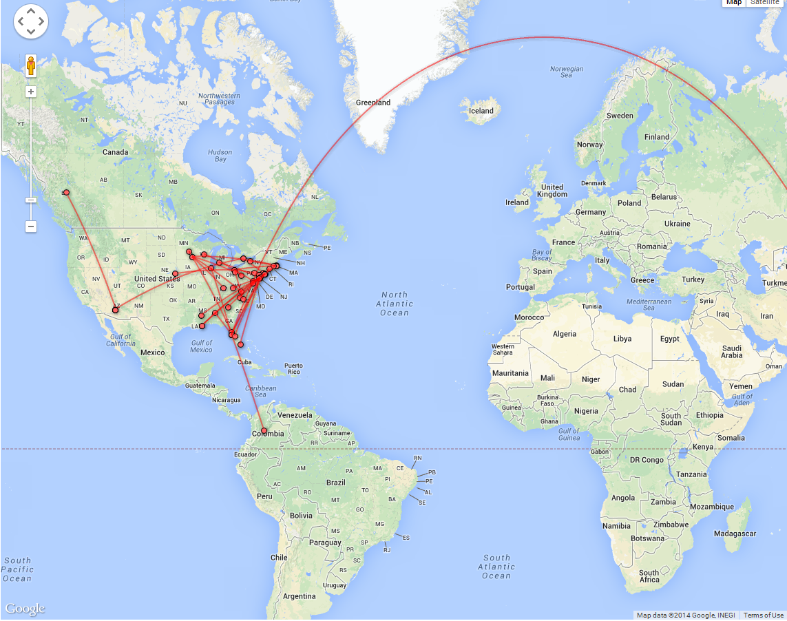

**Figure 5: A KML Gmaps example using Fusion Tables**